SUPERVISION
Date / time: 16/10/2025

Main issues discussed
1. Core goals and stretch goals. The core goal is non-negotiable and must be delivered. The stretch goal should only be pursued if time allows and it is feasible. Do fewer things better, and narrow the scope whenever necessary.
2. Timeline and assessment arrangements. Build the plan around the core goals and prioritise the essential deliverables first. There are three core goals in seven weeks, so roughly one goal should be completed every two weeks. Include redundancy: if one goal is finished early, the extra time can be used to start the next core goal or attempt a stretch goal. Start immediately and show at least a working environment or initial progress next time, rather than waiting until next week.
3. The marking criteria and weightings for the three coursework assignments.
4. Process evidence, record-keeping, and conventions for appendices/links. Continue attending supervision and bringing materials, produce weekly progress, discuss it with the supervisor, record feedback and improvements, and keep evidence. Create a summary table for each supervision session: what I brought, what was discussed, what I asked, how it was answered, and what the next actions are.
5. Will use each one-to-one meeting to give us technical Q&A training.

Work shown
the presentation by my supervisor, John Halloran
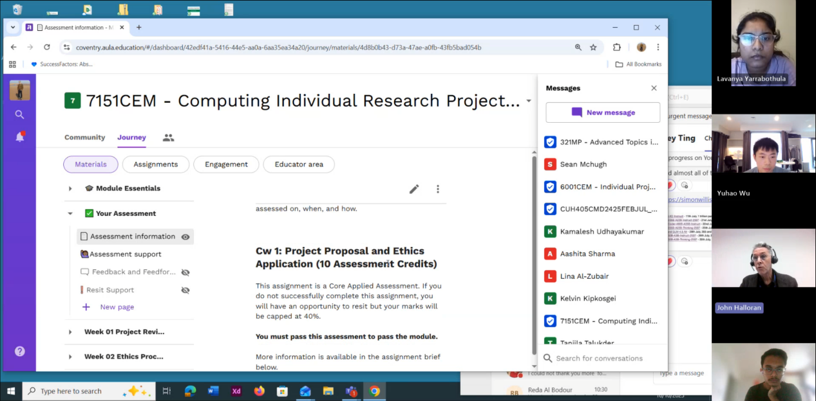

Questions asked; how questions were answered
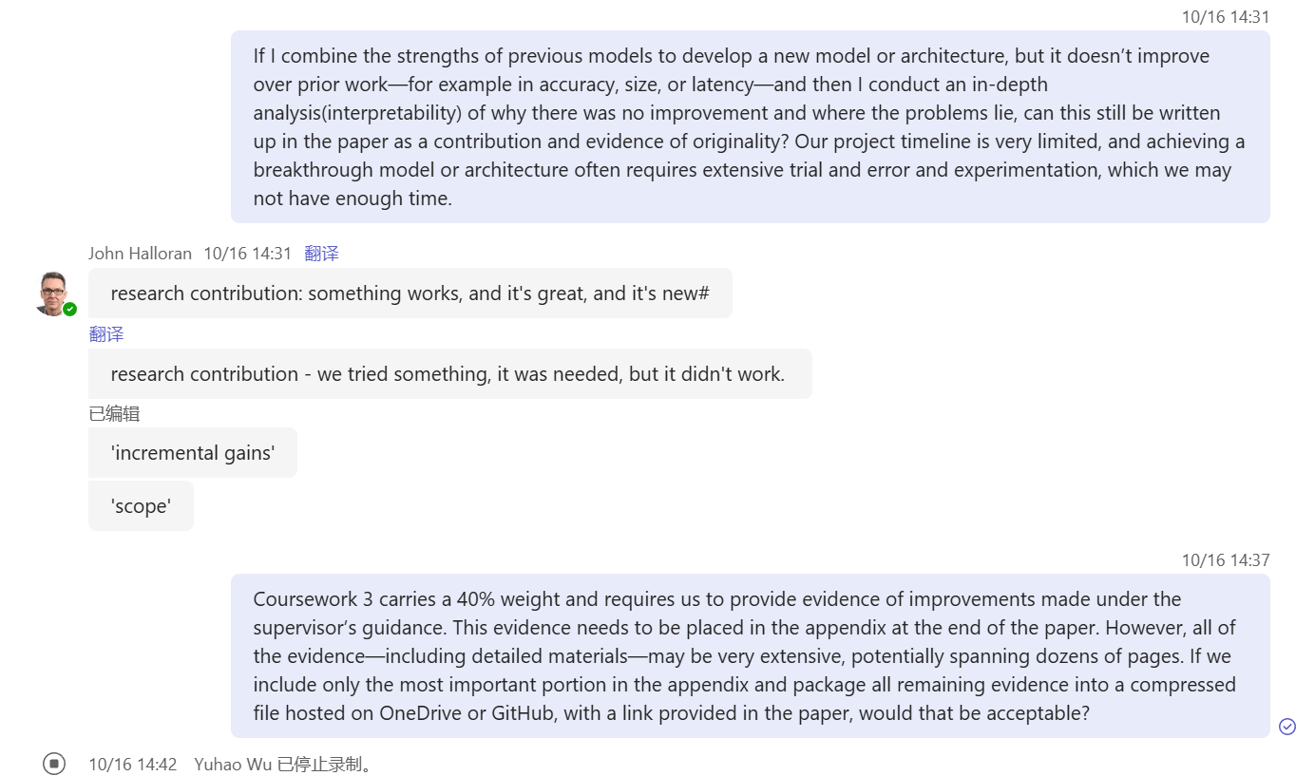
Answer
1. That’s fine. Basically, there are two types of research contributions. The first is: what we did works, it is new, and it is great. This is the ideal kind of contribution. The other is: we tried something that was necessary to try, but it did not succeed.
2. This is absolutely correct; you can do it this way. But links must include context or a summary to avoid “bare links”. For GitHub, prepare a README and reuse or summarise it in the main body or appendix.

Email
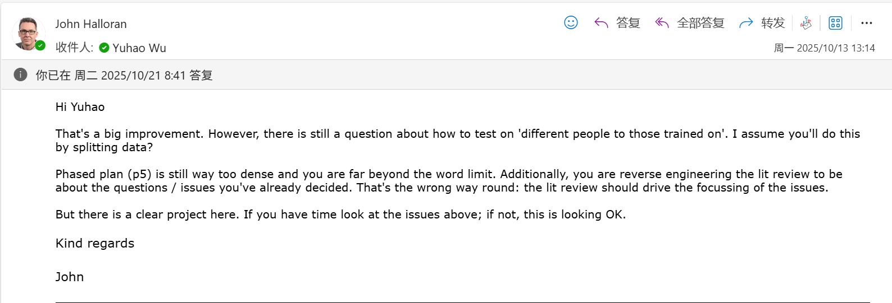

Computing Project
WORK DONE
1. Continue revising the proposal.
2. Train and test the 6 baseline models (knn, random forest, inceptiontime, tst, minirocket and multirocket)on the RealWorld dataset.
3. Start preparing for the preprocessing work on the LARa dataset.

Issues and challenges
- The proposal is still too dense, and its readability is not high enough.
- I’ve used some acceleration methods, but the training speed of MiniRocket and MultiRocket is still very slow.
- The LARa dataset has a different data structure and characteristics from RealWorld, so its preprocessing cannot simply follow the same approach. Making the LARa preprocessing more rigorous, standardised, and well-structured is also a challenge.

Actions for next week
1. Complete the preprocessing of the LARa dataset and train and test several baseline models.
2. Prepare for the work of designing a new model.

Link to recording
https://livecoventryac-my.sharepoint.com/:v:/g/personal/aa1910_coventry_ac_uk/Ed05xER6ysRDkJnvjXC6q6cBfm4uYf7eGohUF6cy_22sig

Backup link (in case the original link expires)
Part 1
https://livecoventryac-my.sharepoint.com/:v:/g/personal/wuy176_uni_coventry_ac_uk/Ef1nFt8IcdJGqUw_kbGrPwEBsle0iDIm5QkyP6yDgpe1YA?e=tndvPM&nav=eyJyZWZlcnJhbEluZm8iOnsicmVmZXJyYWxBcHAiOiJTdHJlYW1XZWJBcHAiLCJyZWZlcnJhbFZpZXciOiJTaGFyZURpYWxvZy1MaW5rIiwicmVmZXJyYWxBcHBQbGF0Zm9ybSI6IldlYiIsInJlZmVycmFsTW9kZSI6InZpZXcifX0%3D

Part 2
https://livecoventryac-my.sharepoint.com/:v:/g/personal/wuy176_uni_coventry_ac_uk/ESDKb0HyMXxEi6y8b65EZ48BjmlL3opsbAuP43YskTDoLg?e=gkeUdb&nav=eyJyZWZlcnJhbEluZm8iOnsicmVmZXJyYWxBcHAiOiJTdHJlYW1XZWJBcHAiLCJyZWZlcnJhbFZpZXciOiJTaGFyZURpYWxvZy1MaW5rIiwicmVmZXJyYWxBcHBQbGF0Zm9ybSI6IldlYiIsInJlZmVycmFsTW9kZSI6InZpZXcifX0%3D

Part 3
https://livecoventryac-my.sharepoint.com/:v:/g/personal/wuy176_uni_coventry_ac_uk/ESXwlFXxNXxGiCQgqjkLpkUBnvd8YGm4NuR3cl5x_ANLvw?e=U5Urat&nav=eyJyZWZlcnJhbEluZm8iOnsicmVmZXJyYWxBcHAiOiJTdHJlYW1XZWJBcHAiLCJyZWZlcnJhbFZpZXciOiJTaGFyZURpYWxvZy1MaW5rIiwicmVmZXJyYWxBcHBQbGF0Zm9ybSI6IldlYiIsInJlZmVycmFsTW9kZSI6InZpZXcifX0%3D

